1. Computation of Angles, Intersection, Planes, Normals to Planes, and Pitch Angles
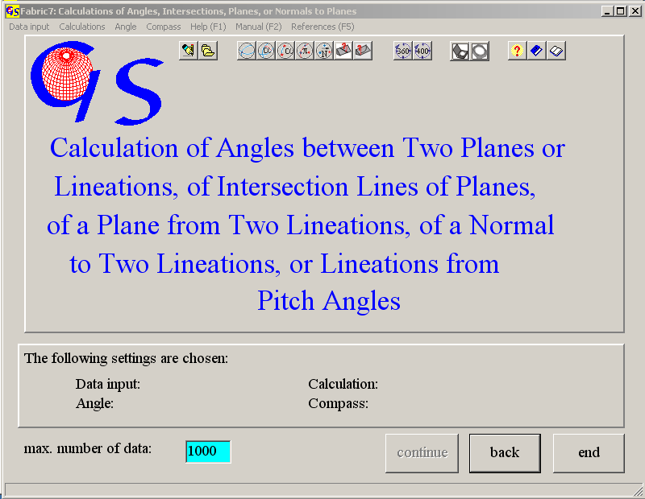
Fig.1

The first page pf the program 1 is shown in Fig. 1 it carries out the calculation of the following elements:

The intersection line of two planes 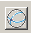,
the angle between two planes ,
the angle between two lineations ,
a plane from two lineations ,
the normal on two lineations ,
the pitch angle from a plan and a lienation in it ,
a lineation in a plane from the pitch angle .

At the beginning the button "continue" is inactive, because the program expects specification of the input procedure (Fig. 2), the type of calculation (Fig. 3), and for manual input the type of angle reading (0 to 360° or 0 to 400°, Fig. 4), and the type of Compass (Clar- or Brunton-Compass), with which the measures were taken (Fig. 5).

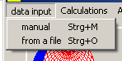 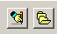 Fig. 2

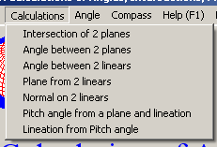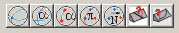
Fig. 3

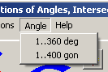
Fig. 4

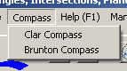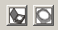
Fig. 5

The selection from these menus is shown on the panel at the bottom of the form (Fig. 6)

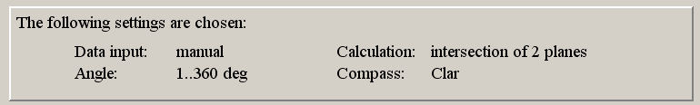
Fig. 6

After these selection the button "continue" is active . Clicking on it brings you to the next form, either to manual input or input from a data file.

1) Manual Data Input:

Fig. 7 shows the form for manual input of data measured with the Clar-Compass and for the calculation of the intersection line between two planes after clicking on "Start". Azimuth of dip and angle of dip must be typed, separated by "return". After the input of the four angles the calculations starts after “return” or clicking in the “OK“ field. Input errors may be corrected before. The calculated values appear in the list (Fig. 7).

Fig. 8 shows the form for manual input of data, measured with a Brunton-Compass. The angle of strike, angle of dip and direction of dip – North (n) or South (s) – must be typed.
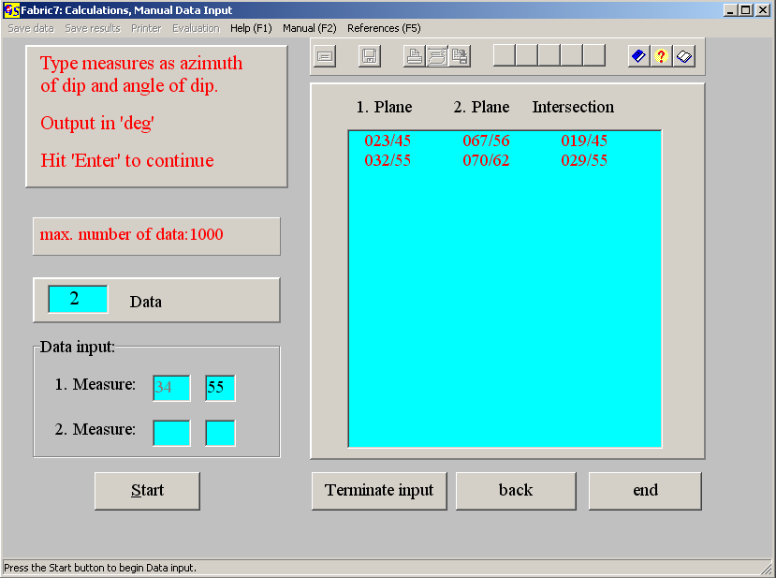
Fig. 7

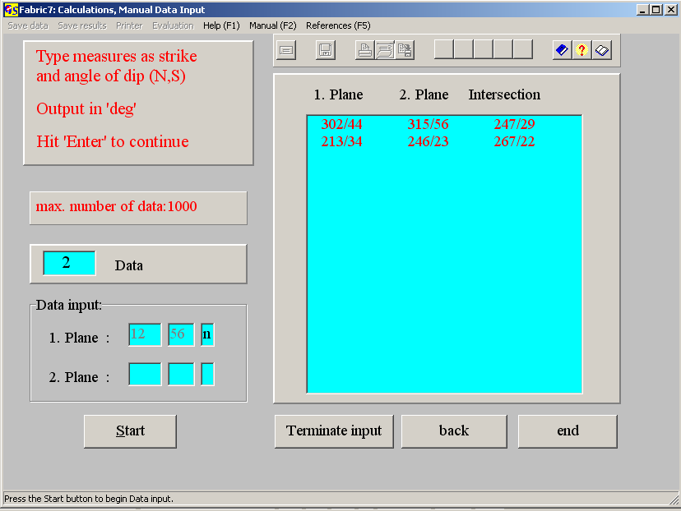
Fig. 8

For calulation of the pitch angle from a plane and a lineation, or for calculation of a lineation on a plane from a pitch angle you have to indicate whether the angle is measured clockwise or counter clockwise (Fig. 9 and 10).

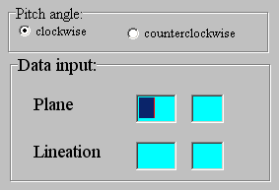 Fig. 9

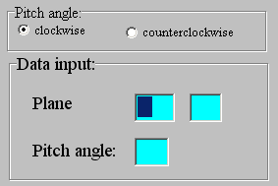 Fig. 10

Note that the data are transformed to the format dip direction / dip angle after calculation.

After input of all data click on "Terminate input". The message in Fig. 11 appears.
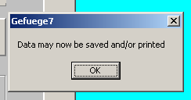 Fig.11

Now Data and results may be saved and/or printed, or written to an *.rtf-file. (Fig. 12 – 14).

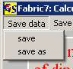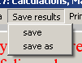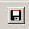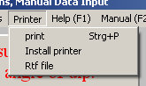
Fig. 12 Fig. 13 Fig.14

Saving of data and results is done as in all other winows-programs.

With the Menu " Other Methods" (Fig. 15) you can jump to the Programs 3, 4, 9, 10, or 11 to plot the data or great circles, to plot contoured diagrams, calculate statistic parameters, or to find submaxima.

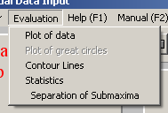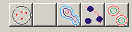
Fig. 15

If the results of the calculations are planes, the result-file gets the extension “.PLA”. For lineations the extension is “.LIN”. If the results are angles, the extension is “ANG”. These extensions are appended automatically. That means that you must type only the name of the file, without extension. You can either use the path which was established in “Install”, or change the path.
In case of the calculation of pitch angles, the input data (planes and lienations on these planes) are saved with the extension *.PLI. In case of the calculation of lineations from pitch angles on planes, the input data are saved with the extension *.PCH.

2) Data Input from a File:
In general, the form for data input from a file is the same in all programs. The form contains three list-fields. On the left a list of all data files which have the same extension appears for the path which is saved in “Fabric7.ini”. By pressing “Find data Path” can change the path.
By clicking on an arbitrary number of file names you choose the data which you want to process. The names are erased in the left field and appear in the middle field. Clicking on a name in the middle field cancels the choice. The cancelled names reappear again in the left field. Clicking on the button “Calculations" starts the procession, and the results are shown in the right field (Fig.14), in addition the menus “save results”, “save data”, and “printer” become active. Instead of printing, data and result can be written into an *.rft-file (Fig.15).
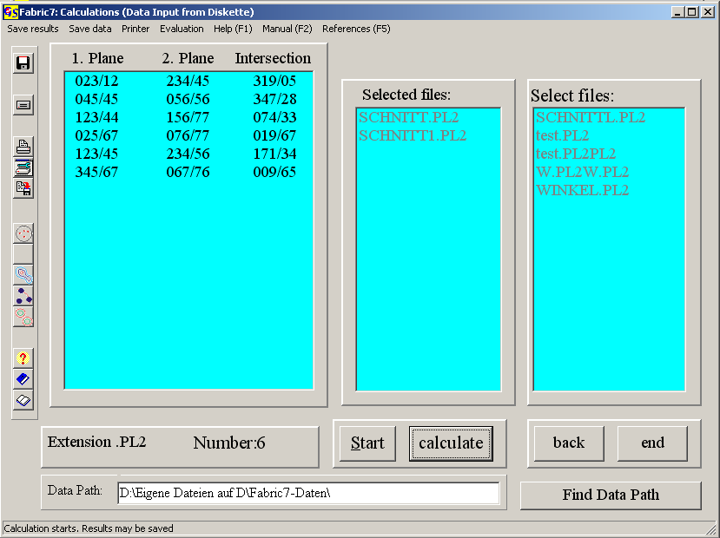
Fig.14

Intersection of Two Planes
Day of calculation: Sunday, 30.April 2006 11.12 h
Filename : SCHNITT.PL2
4 Data
1. Plane: 2. Plane: Intersection:
023/12 234/45 319/05
045/45 056/56 347/28
123/44 156/77 074/33
025/67 076/77 019/67
Fig. 15

The menu "Evaluation" was explained with manual input.

3.1 Calculation of the Intersection Line between Two Planes
This part of the program can be used to calculate a lineation as intersection of two planes (i. e. a δ−lineation from bedding and schistosity). The intersection is calculated from the cross product of the two normals to the planes (WALLBRECHER, 1986:22f.). The calculated lineations are given back as azimuth of dip and angle of dip in a 0-360°-scale. Clicking on “print“ produces a printout of filename, day and time of calculation and a list of data and results. The found lineations can be saved in a file. The path of the directory is written into Fabric7.ini, but may be changed by clicking on the button ‘Find Data Path’. The extension for the file is “.LIN“.

3.2 Calculation of the Angle between Two Planes
This part of the program calculates the angle between two planes through the scalar product of the two normal vectors to the planes. Clicking on “print“ produces a printout of filename, day and time of calculation and a list of data and results. All data are in 0-360°-scale. The calculated angles can be saved in a file. The path of the directory is written in Fabric7.ini, but may be changed in the same way as in Fig. 16. The extension for the file is “.ANG“.

3.3 Calculation of the Angle between Two Lineations
This part of the program calculates the angle between two lines with help of the scalar product of the two vectors representing the lines. Clicking on “print“ produces a printout of filename, day and time of calculation and a list of data and results. All data are in 0-360°-scale. The calculated angles can be saved in a file. The path of the directory is written in Fabric7.ini, but may be changed in the same way as in Fig. 11. The extension for the file is “.ANG“.

3.4 Calculation of a Plane from Two Lineations
This part of the program calculates a plane from two vectors (lineations). This might be necessary if a plane cannot be measured directly, but must be found from two traces of a plane on two different outcrop-planes The plane is determined by the cross product of the vectors of the two lineations (WALLBRECHER,1986:22f). The calculated planes are given in azimuth and angle of dip in a 0-360°-scale. Clicking on “print“ produces a printout of filename, day and time of calculation and a list of data and results. The found lineations can be saved in a file. The path of the directory is written in Fabric7.ini, but may be changed in the same way as in Fig. 16. The extension for the file is “.PLA“.

3.5 Calculation of the Normal to Two Lineations
The normal of the plane which is determined by the two lineations is calculated. The calculation uses the cross product of the two vectors (lineations). The received normal is given in azimuth and angle of dip in the 0-360°-scale. Clicking on “print“ produces a printout of filename, day and time of calculation and a list of data and results. The found lineations can be saved in a file. The path of the directory is written in Fabric7.ini, but may be changed in the same way as in Fig. 16. The extension for the file is “.LIN“.

3.6 Calculation of the Pitch Angle on a Plane from a Lineation
The pitch angle on a plane is the angle between the strike line of the plane and a lineation on the plane. It is calculated from the scalar product of the strike line and the lineation. Output is clockwise in degrees. A protocol (printer or *.rtf-file), in which the filename, day and time of calculation and a list of input data and results are saved can be obtained. The calculated angle can be saved in an ASCII-file. The extension of the filename is ".ANG".

3.7 Caculation of a Lineation on a Plane from a Pitch Angle
The lineation is found by rotation of the strike line trough the pitch angle. Rotation axis is the normal to the plane. A protocol (printer or *.rtf-file), in which the filename, day and time of calculation and a list of input data and results are saved can be obtained. The calculated lineation can be saved in an ASCII-file. The extension of the filename is ".LIN".

